**GlidePath Prototype Development**

**System Design Document**

**Version 4.0, 28 Sep 2016**



11251 Roger Bacon Drive  
Reston, Virginia, 20190

**Revisions**

|  |  |  |
| --- | --- | --- |
| Version | Date | Description of Change |
| 1.0 | 9/30/2014 | Initial Version |
| 2.0 | 10/22/2014 | Software description updates; Draft DVI concept |
| 3.0 | 5/29/2015 | Reflects as-built system. |
| 3.1 | 11/20/2015 | Updated state diagram & table per acceptance test comments. |
| 4.0 | 9/28/2016 | Address CRs 6, 7, 9, 13 |

TABLE OF CONTENTS

1.0 Scope 1

1.1 Identification 1

1.2 System Overview 1

1.3 Document Overview 1

1.4 References 1

2.0 System Design Decisions 2

2.1 System Inputs and Outputs 2

2.2 Design Considerations and Constraints 4

2.3 System Behavior 5

2.4 Approach to Safety and Security 9

3.0 System Design 9

3.1 System Components 9

3.1.1 System Structure 9

3.1.2 Components 10

3.1.3 Performance Estimates 49

3.2 Concept of Execution 49

3.3 Interface Design 52

Appendix A: Datasheets 53

NTCIP Traffic Signal Controller – Econolite ASC/3-2100 53

NTCIP to FHWA SPaT BlackBox – Advantech UNO-2178A 54

DSRC Roadside Unit – Arada Systems Locomate RSU 55

DSRC After-market Safety Device – Arada Systems Locomate ASD/OBU 56

Positioning System – TORC PinPoint 57

In-Vehicle Processor – Axiomtek tBOX312-870-FL 58

AP Router – CradlePoint MBR1400 59

Network Switch – Danpex KN-S7210G 60

Driver Vehicle Interface – Panasonic TOUGHPAD JT-BI 62

Vehicle Electrical/Power System – TrippLite AC UPS/Inverter SMART2600R 64

Appendix B: Acronyms 65

# Scope

## Identification

This document includes design information for the Automated GlidePath Prototype. The Prototype refers to a system of hardware and software that will reside on a vehicle that is equipped with full-range automated longitudinal control capabilities. On top of the base functionality of this vehicle, this document defines additional hardware, including a Dedicated Short-Range Communication (DSRC) DSRC After-market Safety Device (ASD) and an Advanced Positioning System that will be installed to provide input to an In-Vehicle Processor. The In-Vehicle Processor will run the Prototype software, specifically a Speed Control application that uses an Eco-Approach and Departure (EAD) algorithm to calculate the vehicle’s target speed and acceleration, which will be sent to the vehicle’s automated longitudinal controls to be executed by the vehicle. Additionally, the software will provide input and output capability to the Driver-Vehicle Interface, a tablet, which will allow the driver to control the Prototype and view information during operation.

This document also contains information about the supporting Roadside Infrastructure that is necessary to operate the Prototype. This infrastructure includes the traffic controller, a Signal Phase and Timing (SPaT) blackbox, and a DSRC Roadside Unit (RSU), which will be configured to broadcast information to the Prototype to be used as input in the Speed Control application.

## System Overview

The Automated GlidePath Prototype builds off previous research that resulted in the creation and demonstration of the Eco-Approach and Departure algorithm. The demonstration was conducted in 2012, with a single laptop to run an application and a dashboard-mounted tablet to display the target speed to the driver. The purpose of the Prototype is to create a more robust system for demonstration that removes the responsibility of speed control from the driver and also supports additional applications to be developed in future research projects.

## Document Overview

The purpose of this document is to illustrate design decisions for review and discussion by project team members and Federal Highway Administration (FHWA) staff. This document does not contain any sensitive or confidential information; however, the draft version is not intended for external distribution beyond the project team members, FHWA project staff, and oversight contractors. The final version of this document may be published or distributed at the discretion of the FHWA project lead.

## References

The following documents contain relevant information about the GlidePath Prototype and can be obtained by contacting the Saxton Lab staff.

Table . List of Referenced/Relevant Documents

| Reference Number | Document Name |
| --- | --- |
|  | FHWA Statement of Work for TOPR 17, version 4.0 dated February 20, 2014 |
|  | Leidos Proposal for Task Order 17 |
|  | TORC ByWire XGV User Manual, version 1.5 |
|  | UCR’s Eco-Approach and Departure (EAD) Algorithm Report – August 2014 |
|  | SAE/TP 2009-01-3250 – Joint Architecture for Unmanned Systems: A Set of SAE Interoperability Standards |
|  | Saxton Lab Task Order 17: Automated GlidePath Prototype Technical Requirements |
|  | Eco-Signal Operations: Operational Concept, Final Report – October 2013 |
|  | US DOT Specifications for DSRC RSU version 4.0 – April 15, 2014 |

# System Design Decisions

The following sections describe the system inputs and outputs, individual decisions, constraints, and limitations that affected the design described in this document.

## System Inputs and Outputs

**Figure 1** depicts the system data inputs and outputs through the Prototype’s hardware components. The data input required for the Speed Control application includes the following elements:

* Signal Phase and Timing (SPaT) data
* Geometric Intersection Description (GID or “MAP”) data
* Current Position data
* Current Speed data

The Speed Control application feeds these inputs into the Eco-Approach and Departure (EAD) algorithm which calculates a target speed and acceleration that will reduce the fuel consumption and emissions of the vehicle as it approaches a signalized intersection, based on the amount of time left in the current signal phase. The target speed and acceleration output is then routed both to the Automated Longitudinal. The Automated Longitudinal Controller then implements the target speed and acceleration by controlling the vehicle’s brake and throttle. The DVI then displays information to the driver, and provides a mechanism for the driver to control the operation of the prototype; including buttons to engage/disengage the automated functionality and to select the operating speed of the prototype.

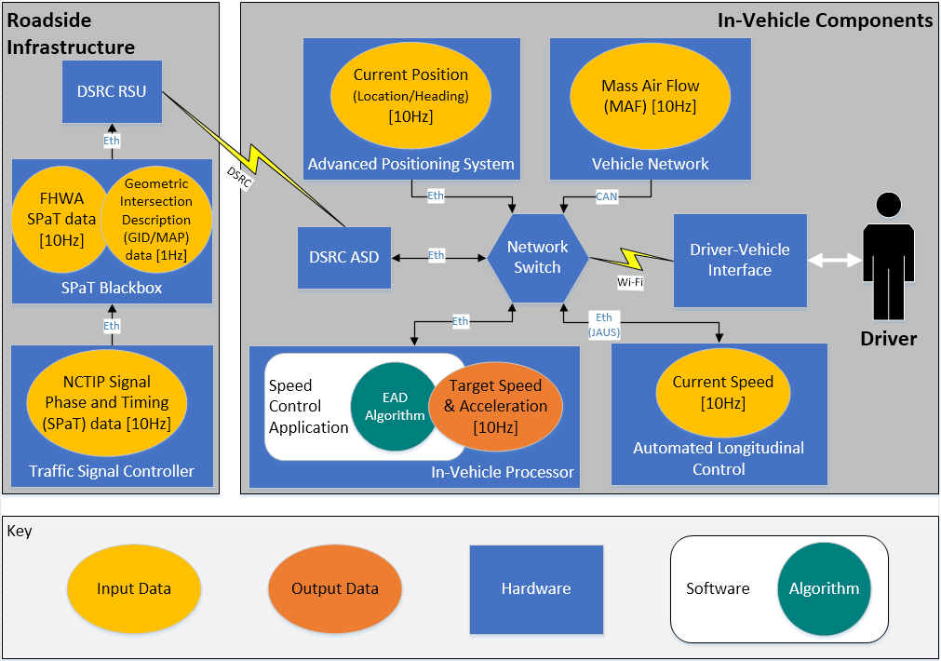

Figure . Graphical Depiction of GlidePath System Inputs and Outputs

## Design Considerations and Constraints

This section notes several important considerations that were made as part of the design, including the selection of the ByWire XGV vehicle, the use of a tablet for the DVI, the data transmission frequency, and the emergency override options for the prototype. The design of the Prototype is unconstrained by site-specific considerations; however, a few limitations of the selected demonstration site are discussed below.

Prototype Vehicle Selection

The design and development of this Prototype is being conducted on an accelerated schedule to ensure the outcomes align with the overall FHWA Research Program. To minimize the amount of time required for development, the project team explored options for vehicles that had already been equipped with full-range Automated Longitudinal Control capabilities in both forward and reverse directions. The ByWire XGV was selected because it has a robust Speed Control system that allows for direct control of the vehicle’s brake and throttle and is also compliant with other high-level Prototype requirements.

EAD Algorithm Selection

The University of California, Riverside (UCR) completed the original research that concluded in 2012 with the development of an EAD algorithm. This algorithm was tested in preliminary demonstrations that provided the algorithm output (target speed) to a driver to implement on the vehicle and showed up to eighteen (18) percent fuel savings in field tests. The same EAD algorithm was selected for use in the Prototype to avoid redundant development efforts and to potentially leverage additional development that has been done on the algorithm since 2012 to incorporate adaptive signal control in future expansion.

Driver-Vehicle Interface

The project team considered using physical buttons to provide input mechanisms to the driver, but opted instead to use a tablet with a customized, graphical DVI. Use of a tablet will allow for software-based control of the DVI, which will enable modification and expansion of the application and Prototype vehicle to support future research as necessary. Additionally, to mitigate the risk of a software-related error, the emergency override options discussed below ensure that the driver has physical control over the operation of the vehicle at all times.

Data Transmission Frequency

Most of the data input elements that are required for the Automated GlidePath Prototype are dynamic, with the exception of the Geometric Intersection Description (GID or “MAP”) data, which is specific to each intersection/roadway but is otherwise static. The Prototype calculates the target speed and acceleration in near real-time, and must be updated at a frequency greater than once per second (1Hz) to ensure provision for safe-stop in operational cases that require the vehicle to come to a complete stop at the intersection or catch the last second of green-time. To accommodate for near real-time calculation, all dynamic input data elements will be aggregated at 10Hz.

Emergency Override

As discussed in Section 2.4 *Approach to Safety and Security*, and as specified in the Prototype Requirements, the Prototype must include two (2) physical mechanisms to override automated control of the vehicle[1]. The first mechanism is the brake pedal, which will disable automated control of the vehicle when depressed by the driver during automated operation of the Prototype. The second mechanism is a yellow button, installed in the center console within easy sight and reach of the driver, which can be used to disengage automated control. With both mechanisms, the gear shift must be moved back to the “D” position to enable manual control of the vehicle

Site-specific Considerations

The Prototype design is intended for use at the Turner Fairbank Highway Research Center (TFHRC) in McLean, Virginia, but its functionality is intended to operate at any signalized intersection that is equipped with the supporting Roadside Infrastructure described in this document, and configured to broadcast the SPaT and GID data. Additionally, the Prototype design is suitable for use only at a single, fixed-timing signalized intersection that is sheltered from outside vehicles. Future research may be conducted to include multiple intersections, vehicles, or adaptive-timing plans.

## System Behavior

The GlidePath Prototype and its subsystems can be controlled by several input mechanisms that, in combination, serve as transitions between the vehicle states which are depicted in **Figure 3**. These state transitions are defined in the Requirements document, listed as item #6 in **Table 1**. The following sections define the input mechanisms and their prescribed use – alternative operation of the Prototype outside of these guidelines is not recommended.

Definition of Input Mechanisms:

* **Ignition Key** – physical mechanism to start/turn off the vehicle’s engine, located to the right of the steering wheel.
  + **Off** – when the key is in the “off” position, the vehicle’s engine is off and the vehicle will not move.

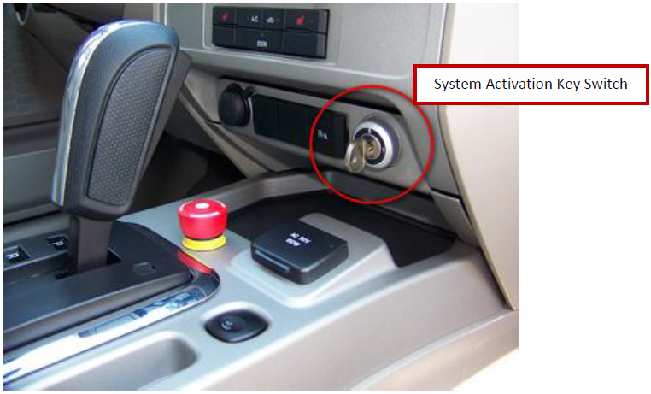

Activation Key

Figure . Picture of XGV Activation Key

* + **On** – when the key is in the “on” position, the vehicle’s engine will be turned on and the input mechanisms defined below will govern the movement of the vehicle.
* **Activation Key** – physical mechanism to activate XGV controller and provide power to the automated control systems. The key is located on lower right side of the center console in the front of the vehicle, as depicted in Figure 2.
  + **0** – when the key is in the “0” position, the automated systems are disabled and the vehicle operates in accordance with its stock functionality.
  + **1** – when the key is in the “1” position, the automated systems can be enabled by shifting the Gear Shift to the “N” position and can be activated through the DVI.
* **Gear Shift** – physical mechanism to switch between Parked, Manual and Automated states. When the vehicle ignition is turned off, the gear shift will be in the “P” position, when the vehicle ignition is turned on, the gear shift will behave in accordance with the following protocol:
  + **P** – when the gear shift is in the “P” position, the prototype will remain in the Parked state and the vehicle will not move.
  + **D** – when the gear shift is in the “D” position, the prototype will be in the “Manual” state and the vehicle will operate in accordance with its stock functionality.
  + **R** – when the gear shift is in the “R” position, the prototype will operate in accordance with its stock functionality.
  + **N** – when the gear shift is in the “N” position, the prototype will transition between the “Automated,” “EcoDrive,” and “Idle” states using input from the DVI, brake, and emergency button in accordance with the state transitions, depicted in Figure 2.
* **Brake Pedal** – the brake pedal is the physical mechanism located on the floor of the driver’s seat that can be used by the experimenter to reduce the speed of the vehicle when the ignition is turned on.
  + When the gear shift is in the “P” or “D” positions, the brake pedal will operate in accordance with the vehicle’s stock functionality.
  + When the gear shift is in the “N” position, the brake pedal will operate in accordance with the vehicle’s stock functionality and will also serve as a manual override to deactivate the automated systems when depressed by the Experimenter.
* **Gas Pedal** – the gas pedal is the physical mechanism located on the floor of the driver’s seat that can be used by the Experimenter to increase the vehicle speed when the ignition is turned on.
  + When the gear shift is in the “D” position, the gas pedal will operate in accordance with the vehicle’s stock functionality.
  + When the gear shift is in the “N” position, the gas pedal will not control the vehicle speed.
* **Emergency Button** – the emergency button is a button that is located on the center console in the front of the vehicle and can be activated when the gear shift is in the “N” position.
  + When the prototype is in the “EcoDrive” state, the Experimenter can press the emergency button to manually override the automated systems.
  + When the prototype is in the “Idle” state, the Experimenter can press and twist release the emergency button as one of the conditions necessary to transition to the “Automated” state.
* **Driver-Vehicle Interface (DVI)** – the DVI is the platform that will be used to accept inputs from the Experimenter to control the automated system.



Figure 3. Glidepath Prototype State Diagram

Table . Description of GlidePath Prototype Operating States

|  |  |  |  |  |  |  |
| --- | --- | --- | --- | --- | --- | --- |
| # | State Name | Definition | Ignition | Activation Key | Shift Position | Automated Control |
| 0 | Ignition Off | All systems are off. | Off | 0 | P | Disabled |
| 1 | Park | Vehicle engine is running, component systems power up, vehicle does not move. | On | 1 | P | Disabled |
| 2 | Manual | Driver has full control of the vehicle and is responsible for safe operation on the road. | On | 1 | D | Disabled |
| 3 | Automated | Automated control is enabled, but not engaged; user must initiate automated system or transition to manual control. | On | 1 | N | Enabled |
| 4 | EcoDrive | Automated control is engaged to control the longitudinal movement of the vehicle; driver must control lateral movement, re-engage automated control after a full stop, and revert to manual control as needed to ensure a safe demonstration of the prototype. | On | 1 | N | Actively Engaged |
| 5 | Idle | Automated controls have been disabled by driver intervention and must be reset before DVI can engage EcoDrive. In this State, the vehicle will revert to the stock vehicle “Neutral” operation. | On | 1 | N | Disabled |
| 6 | Idle with Brake | Automated controls are disabled and brake is gently applied to bring vehicle to a smooth stop. | On | 1 | N | Disabled |

## Approach to Safety and Security

Several provisions for safety and security are included in the inherent design of the Prototype and additional operational security procedures have been defined to further prevent improper use of the Prototype that may compromise safe operation of the vehicle.

As discussed in Section 2.2 *Design Considerations and Constraints,* two (2) physical mechanisms are included in the design for physical, manual override of the automated functionality of the Prototype. Both the brake pedal and yellow emergency button will disengage automated control of the vehicle during a demonstration or test, and control is returned to the driver by moving the gear shift back to the “D” position.

In accordance with the Physical Security Requirement for the Prototype, the key to the vehicle will be stored in a secured, locked location when the Prototype is not in use by authorized staff to avoid improper use of the vehicle by unauthorized personnel. Additionally, operational security will be maintained by ensuring that the vehicle is always attended by an authorized staff member during testing and demonstration, and requiring driver input prior to re-engaging automated speed control after a full stop during demonstration.

Finally, the In-Vehicle Processor will be protected by a single-layer of authentication with a username and password to prevent unauthorized modification of the Speed Control application or Eco-Approach and Departure algorithm.

# System Design

This section illustrates the system design, as broken down into the overall system structure – with high-level architecture diagrams for the system hardware and software – and then into individual hardware and software components. A subsection is included for each individual component to describe the component’s purpose and interface with other components, as well as to provide additional background on individual design decisions. In the final version of this document, detailed diagrams will be provided to depict individual component interfaces to specific ports, channels, etc.

## System Components

### System Structure

**Figure 4** depicts the high-level structure of the hardware for the Automated GlidePath Prototype, its subsystems, and the supporting Roadside Infrastructure. As depicted below, the following subsystem components will be installed in the GlidePath Vehicle to be connected via Ethernet to the In-Vehicle Processor to provide inputs to the Eco-Approach and Departure (EAD) algorithm and Speed Control application:

* DSRC After-market Safety Device (ASD)
* Advanced Positioning System
* Vehicle Network
* Automated Longitudinal Controller
* Driver-Vehicle Interface
* In-Vehicle Processor

Additional information about the individual hardware components listed in the diagram below is included in Section 3.1.2 *Components.*

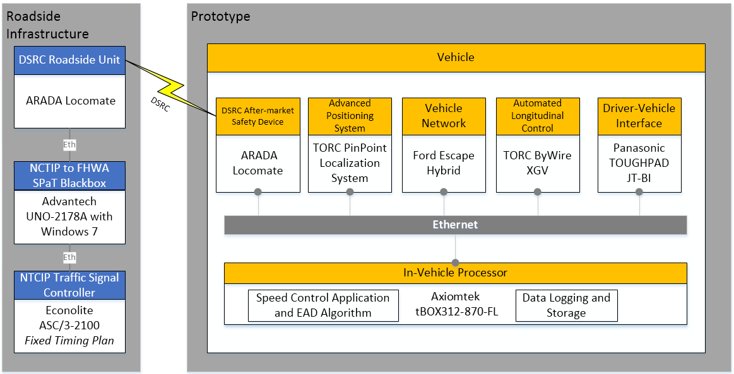

Figure . High-Level Hardware Architecture Diagram

### Components

This section includes a list of all hardware and software components, as well as individual component descriptions to provide supporting details, including technical specifications, features, and functionalities that were relevant to their selection for the design of the Prototype.

Table . Hardware Component List

| Component # | Component Name | Hardware Manufacturer | Model Name/Number |
| --- | --- | --- | --- |
| 1 | NTCIP Traffic Signal Controller | Econolite | ASC/3-2100 |
| 2 | NTCIP to FHWA SPaT BlackBox | Advantech | UNO-2178A running Windows 7 |
| 3 | DSRC Roadside Unit | Arada Systems | Locomate |
| 4 | DSRC After-market Safety Device | Arada Systems | Locomate[2] |
| 5 | Positioning System | TORC | PinPointTM |
| 6 | Vehicle with Automated Longitudinal Control | Ford/TORC | Escape Hybrid/XGV ByWire |
| 7 | In-Vehicle Processor | Axiomtek | tBOX312-870-FL |
| 8 | AP Router | CradlePoint | MBR1400 |
| 9 | Network Switch | Danpex | KN-S7210G |
| 10 | Driver Vehicle Interface | Panasonic | TOUGHPAD JT-BI |
| 11 | Vehicle Electrical/Power System | TORC | HVDC 330V-54V DC/DC Converter |
| TORC | 24V PowerHub Intelligent Power Distribution (PH482402) |
| TORC | 12V PowerHub Intelligent Power Distribution (PH481202) |
| TrippLite | AC UPS/Inverter SMART2600R |

#### Infrastructure

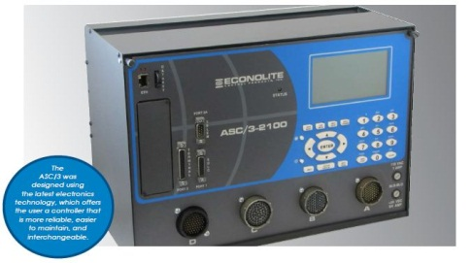**Figure 5**, a subset of the overall GlidePath hardware architecture diagram from Figure 4, depicts the three major hardware components of the GlidePath prototype’s roadside infrastructure, including the Traffic Signal Controller, NTCIP to FHWA SPaT Translator (Blackbox) and the DSRC Roadside Unit (RSU). Signal Phase and Timing (SPaT) data is generated by the Traffic Signal Controller and sent over Ethernet to the blackbox, which converts the data to a DSRC SPaT message and transmits it to the DSRC RSU. The following sections describe these individual components, and additional technical details for each component are available in Appendix A *Datasheets.*

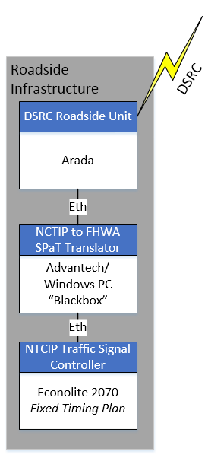

Figure . Roadside Infrastructure subset of Hardware Architecture Diagram

1. **Traffic Signal Controller (Econolite ASC/3-2100)** The hardware selected for the traffic signal controller is the Econolite ASC/3-2100 unit that is installed in the cabinet at the Turner Fairbank Highway Research Center’s (TFHRC’s) Intelligent Intersection. The ASC/3-2100 is a shelf-mounted, fully actuated, digital, solid-state traffic signal controller with a back-lit, dynamic display for programming and monitoring the operational status and configuration of the controller. All interface connectors are accessible from the front of the controller, which will be housed in the traffic controller cabinet at the TFHRC Intelligent Intersection. Additional technical details are available in the Econolite Datasheet, included in Appendix A *Datasheets.*
2. 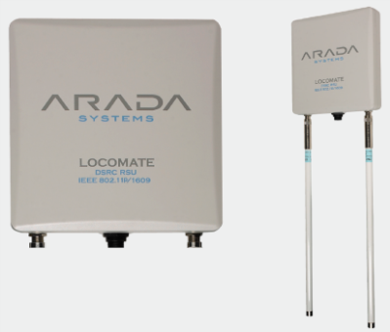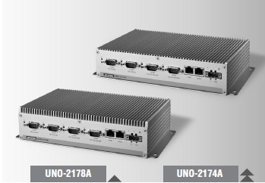**Signal Phase and Timing (SPaT) BlackBox (Advantech UNO-2178A)** The hardware selected for the traffic signal controller is the Advantech UNO-2178A which is a compact, industrial-grade processor that is rated for high operating temperatures that are common in traffic controller cabinets. The blackbox will be housed in the Saxton Lab Annex and connected to the Traffic Signal Controller remotely, from which it will receive Signal Phase and Timing data as input over Ethernet as a collection of NTCIP objects and output the data over Ethernet to the DSRC Roadside Unit (RSU) as a standard DSRC SPaT message at 10Hz. Additional technical details are available in the Arada Datasheet, included in Appendix A *Datasheets.*
3. **Dedicated Short-Range Communication (DSRC) Roadside Unit (RSU) (Arada Systems Locomate)** The Arada RSU is an industrial NEMA/IP67 rated outdoor wireless radio with omni, bi-directional antennas that uses Power-over-Ethernet (PoE). Two (2), pole-mounted radios will be used to support the Prototype, with power running from supporting Roadside Electronics Cabinets that will house the PoE injectors, which also provides the Ethernet interface to the blackbox. As depicted in **Figure 6**, the two radios are set-up in a Primary/Secondary configuration, where the RSU installed near the traffic signal controller (RSU A) will receive and broadcast the SPaT message from the blackbox at 10Hz and the RSU installed along the test roadway (RSU B) will receive and repeat the SPaT broadcast from RSU A, which will extend the effective range of communication – dependent on line of sight – around the bend in the test roadway.

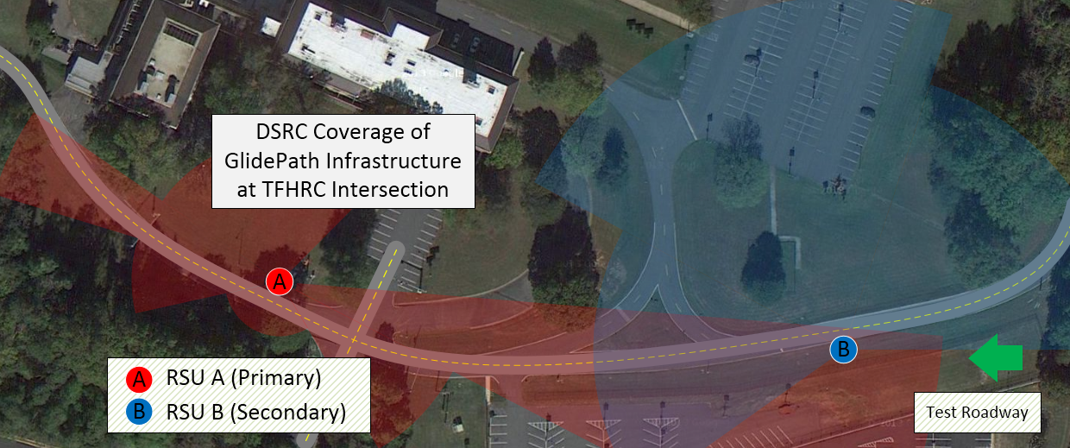

Figure . Effective Range of DSRC Communication at the TFHRC Intelligent Intersection

#### Vehicle Platform

The GlidePath Prototype Vehicle Platform is comprised of several subsystems that are described in this section and depicted in **Figure 7** on the next page, including the DSRC After-market Safety Device (ASD), the advanced positioning system, the Vehicle Network, the Automated Longitudinal Controller, the Driver-Vehicle Interface (DVI), as well as the in-vehicle processor. These components are connected by Ethernet to facilitate data exchange, which ultimately serves the Speed Control application and EAD algorithm to calculate the output target speed and acceleration. The following sections describe these individual components, and additional technical details for each component are available in Appendix A *Datasheets.*

Additionally, the vehicle platform contains an extended power distribution system that stems from the native vehicle’s battery pack to serve power to the individual GlidePath subsystems.

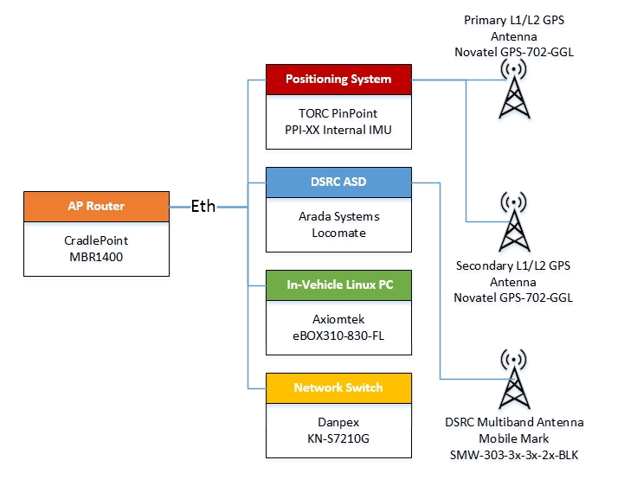

Figure . Vehicle Platform Component Hardware Architecture

1. 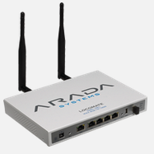**DSRC After-market Safety Device (ASD) (Arada Locomate)** The Arada ASD selected for the GlidePath prototype can be installed in a vehicle to receive SPaT and MAP messages over DSRC at 10Hz and 1Hz, respectively. For the GlidePath Prototype, the ASD acts as middleware between the DSRC RSU and the In-Vehicle Processor, providing data from the roadside to the In-Vehicle Processor for use in the Speed Control application (SpeedControl.jar). The ASD has a dual-radio and connects to a single multiband antenna that is magnetically mounted to the top of the vehicle to provide GPS input to the ASD. Additional technical details are available in the Arada Datasheet, included in Appendix A *Datasheets.*
2. 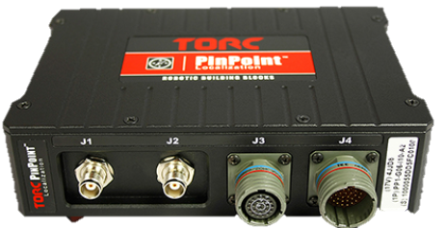**Positioning Subsystem (TORC PinPointTM)** TORC’s PinPointTM localization system was selected for use in the GlidePath Prototype to provide continuous positioning to the prototype, regardless of GPS fix, to enable operation during GPS signal loss or degradation. **Figure 8** depicts the PinPointTM system, which is based on an extended Kalman filter that propagates estimates of the vehicles position, velocity, and altitude as the vehicle moves, using GPS data from two external antennas as well as wheel speed sensors for corrections. The PinPoint internal IMU is connected to the In-Vehicle Processor via Ethernet and outputs position data for use by the Speed Control application (SpeedControl.jar). Additional technical details are available in the TORC PinPoint Datasheet, included in Appendix A *Datasheets.*

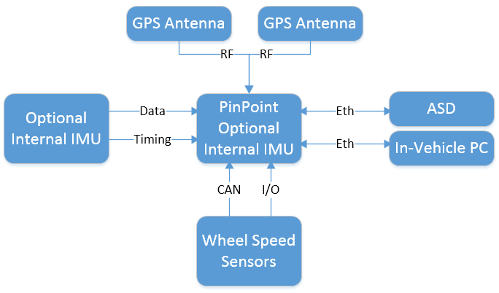

Figure . TORC PinPointTM Block Diagram

1. **Vehicle equipped with Automated Longitudinal Control (2010 Ford Escape Hybrid with TORC ByWire XGV)** The vehicle selected for the prototype is a Ford Escape Hybrid that has been modified by TORC Robotics to enable fully automated, independent (i.e., decoupled) lateral and longitudinal control in both the forward and reverse directions. The TORC ByWire XGV vehicle platform is a multi-component system consisting of the vehicle, multiple hardware subsystem control modules, a central embedded controller, and a TORC SafeStop ES-220 multi-level wireless emergency stop system. The vehicle platform will support the GlidePath Prototype by providing ****automated speed control functionality, access to the vehicle CAN network, power distribution, and an emergency stop system. The TORC ByWire XGV User Manual is on file at the Saxton Lab and available upon request.

Automated Longitudinal Control System

The GlidePath Prototype will achieve automated, longitudinal speed control using closed loop drive-by-wire control available on the vehicle platform. The ByWire XGV Controller allows a user or a computer to command a desired acceleration and desired speed. **Figure 9** provides an overview of ByWire XGV communications between the In-Vehicle Processor and the brake, throttle, and shifting modules that implement automated longitudinal control. Note: The white boxes in **Figure 9** depict components of the XGV ByWire system that are not active in the GlidePath Prototype, including the SafeStop/E-Stop functionality as well as the steering module, which may be used in future research.

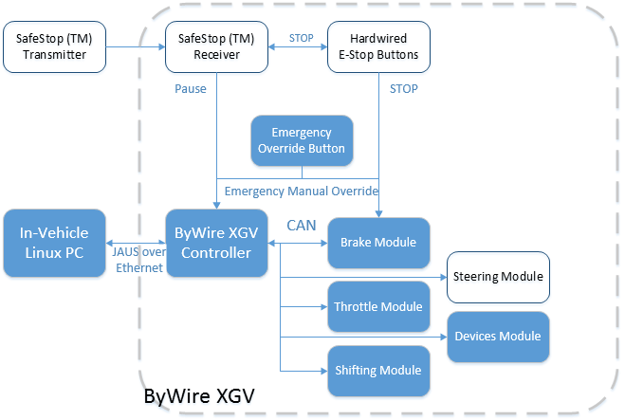

Figure . ByWire XGV Automated Longitudinal Control System Architecture

The communications interface for the ByWire XGV vehicle platform is JAUS (Joint Architecture for Unmanned Systems) over Ethernet and operates using JAUS version 3.3 messages primarily. The In-Vehicle Processor will interface with the XGV Controller, which operates as a JAUS node within the vehicle subsystem and runs six JAUS components, to command and monitor the vehicle via JAUS messages. The XGV expects to receive incoming JAUS messages at port 3794 and transmits all outgoing messages (back to the In-Vehicle Processor and other system components) over the same port.

1. 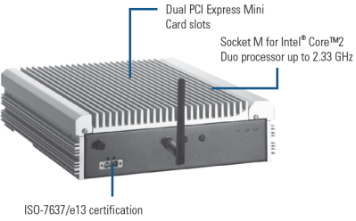**In-Vehicle Processor (Axiomtek tBOX312-870-FL)** The In-Vehicle Processor will be the primary computing platform for the GlidePath Prototype and will run all software necessary to support the EAD algorithm and run the Speed Control application on the vehicle.  The PC is a rugged, fanless system with an Intel Core i7 processor designed for vehicle applications.  Ubuntu 14.04 LTS will be installed on the PC as the operating system.  The Speed Control application that will be hosted on the PC will receive position, heading, and speed information from the positioning system, receive SPaT and GID messages from the DSRC ASD, send and receive information from the ByWire XGV controller, receive data directly from the vehicle Controller Area Network (CAN) via the Onboard Diagnostics (OBD-II) port, and execute the Eco-Approach and Departure Algorithm.  Additional technical details are available in the Axiomtek Datasheet, included in Appendix A *Datasheets.*

Web Interface Functionality

The Speed Control application will be a web-based application that supports the Driver-Vehicle Interface (DVI). Any device connected to the wireless access point on the vehicle (described below) will be able to access the DVI information from a web browser; however, only a single tablet will be registered with the Speed Control application to access the DVI controls. The web application consists of a Spring Boot v1.1.6 Java application using an embedded Tomcat v7.0.55 server, which utilizes WebSockets to facilitate bi-directional communication that differs from the normal web application request/response model to allow the driver to both issue commands and view near real-time data via the browser-based User Interface (UI).

Data Logging and Storage Functionality

The Speed Control application (as described in the Software components section of the document) will record essential information, such as user inputs, speed commands, and vehicle state data, during each experimental drive. This information will be recorded in one or more human-readable log files on the In-Vehicle Processor, and will be off-loaded for post-processing.

1. 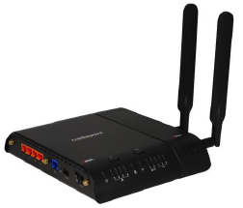**AP Router (CradlePoint MBR1400)** The CradlePoint MBR1400 is a router which will establish a local network and facilitate Ethernet or WiFi access to all GlidePath Prototype components. The router will serve as the communication hub for all Ethernet devices. It will be used in combination with the network switch described below, which will provide additional physical Ethernet ports to support system expansion. Additionally, the CradlePoint supports a cellular connection via USB modem which will provide internet access to the network. Additional technical details are available in the CradlePoint Datasheet, included in Appendix A *Datasheets.*
2. 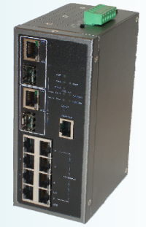**Network Switch (Danpex KN-S7210G)** The Danpex network switch is a rugged, ten (10)-port industrial L2 Managed Switch with eight (8) Ethernet ports and two (2) TP/SFP gigabit dual-media ports. This switch will be installed in the vehicle to provide additional Ethernet ports for the vehicle platform components, as depicted in Figure 7. The selected switch is rated for high operating temperatures, suitable for use in the vehicular environment. Additional technical details are available in the Danpex Datasheet, included in Appendix A *Datasheets.*
3. **Driver-Vehicle Interface (Panasonic TOUGHPAD JT-BI)** 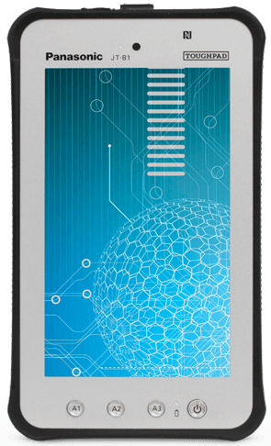The proposed driver vehicle interface (DVI) is a 7-inch rugged tablet powered by Android 4.0 with a daylight-readable display and all-weather dust and water resistant design.  The tablet will be mounted on the center dash and accessible to the driver with either a stock or custom mount.  The DVI content will be displayed via the web browser on the tablet supported by the web server running on the in-vehicle processor as described above.  The web content will be designed to display effectively with the Google Chrome mobile web browser but should be similarly supported by most common mobile platform web browsers including Mozilla Firefox and Safari.  The DVI content includes:

* Engage/disengage EcoDrive state button which also serves as a visual indicator of the current state of the system (i.e., enabled/disabled).
* Intersection Departure button and auditory alert – a ‘GO’ button to facilitate driver approval for the vehicle to proceed when at a full-stop at the intersection at the point when the traffic light turns from RED to GREEN along with an auditory indicator when driver input is required.
* Signal Phase and Timing Display – a visual indicator to show the traffic light state (i.e., red, yellow, or green) and the corresponding countdown in seconds.
* Motion Status Indicator – a visual indicator that depicts the status of the vehicle motion as controlled by the Application (i.e., accelerating, coasting, or braking).

1. **Vehicle Electrical/Power System.** The proposed electrical system shown in Figure 10 below will distribute power to the components added to the XGV platform (Table 4). The proposed electrical design will rely only on the stock Ford Hybrid Escape for power, which has a 330V hybrid battery capable of 3000W of peak power. Power distribution on the vehicle will consist of one (1) high voltage DC/DC converter to transition the 330VDC to a usable 54VDC system and two (2) TORC PowerHub managed power conditioning units to convert 54VDC to 24VDC and 12VDC, separately, to power the various components installed on the vehicle. The TORC PowerHub units each provide eight (8) available power outputs and allow convenient control over Ethernet to switch and monitor each remotely. The TORC PowerHub User Manual is on file at the Saxton Lab and available upon request. One (1) TrippLite SMART2600R AC UPS/Inverter will be installed to achieve shore power and 110VAC accessory power as needed. Additional technical details are available in the TrippLite Datasheet, included in Appendix A *Datasheets.*

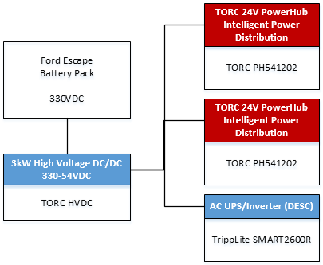

Figure . Vehicle Electrical/Power System Design

The resulting electrical/power system provides 500W at 24VDC and 400W at 12VDC via the PowerHub units with eight (8) outputs each and 2000W VAC available via the UPS/Inverter with eight (8) AC outputs. Table 4 below provides the power requirements by component, showing both those that provide power (+) and those that draw (-) power. The proposed components will consume an estimated 55W of 24VDC, 44W of 12VDC, and 110W of 110VAC leaving over 400W, 300W, and 1800W, respectively, for researcher laptops or other components. The total power consumption of the system is easily supported by the power that the vehicle is measured to produce at idle.

Table : Power Generation/Consumption per Component

| Component | Voltage (VDC) | Peak Current (Amps) | Maximum Power (Watts) |
| --- | --- | --- | --- |
| TORC HVDC | 54VDC |  | 3000 (+) |
| TORC 24VDC PowerHub | 24VDC | 9 (per output) | 500 (+) |
| TORC 12VDC PowerHub | 12VDC | 9 (per output) | 400 (+) |
| UPS / Inverter | 110VAC |  | 2000 (+) |
| DSRC After-market Safety Device | 12VDC | 2 | 24 (-) |
| Positioning System | 12VDC | 1 | 12 (-) |
| In-Vehicle Processor | 24VDC | 1.8 | 43.2 (-) |
| Network Switch | 24VDC | 1 | 12 (-) |
| 4G Cellular AP Router | 12VDC | 1.5 | 8 (-) |
| Driver Vehicle Interface Tablet | 110VAC | 1 | 110 (-) |
| Summary | | | |
| 24VDC Power  Generation / Consumption |  |  | **500 (+) / 55 (-)** |
| 12VDC Power  Generation / Consumption |  |  | **400 (+) / 44 (-)** |
| 110VAC Power  Generation / Consumption |  |  | **2000 (+) / 110 (-)** |

#### Vehicle Speed Control Software

**Figure 11,** below, depicts the vehicle components, highlighting the software components in green. The **Speed Control application** runs on the In-Vehicle Processor after being invoked by the Apache start page. Upon startup it reads the config file to set a variety of parameters. Once started, it collects inputs from the TORC PinPointTM controller, the XGV ByWire vehicle controller and DSRC ASD over Ethernet, and provides necessary state information to its internal Eco-Approach and Departure (EAD) algorithm to calculate target speed and the necessary acceleration commands. The Application then sends the target speed and acceleration output over Ethernet to the XGV ByWire Controller to implement the vehicle’s speed accordingly. Simultaneously, the Application sends the vehicle’s actual speed, distance to stop bar, and the traffic signal’s phase and time remaining to the Driver-Vehicle Interface (DVI) tablet and any observer devices to be displayed. Finally, the Speed Control application will record log files with performance data from the experiment that can be post-processed to analyze the environmental performance of the application.



Figure . High-Level Software Architecture Diagram

The Speed Control Application component consists of several packages. These packages are identified in Table 5, below. The Speed Control Application will be written in Java because it presents a more straightforward approach to multi-threading than C++, and otherwise avoids many technical risks with C or C++.

The design convention for all of this software is that, unless explicitly stated to the contrary, all units of measure use the metric system. Specifically, time is in seconds, distance is in meters, speed in m/s, acceleration in m/s^2 and jerk in m/s^3.

Table 5. Software Component List

| Component # | Package Name | Responsibility |
| --- | --- | --- |
| 1 | Glidepath | The top level package defines some fundamental interfaces that will be used by most of the other packages. |
| 2 | DVI | Holds the main program that sets up & manages all threads and other packages. Runs the master timing thread. Manages shared objects. Provides the UI. |
| 3 | XGV Handler | Communicates with XGV to receive vehicle state and to send target speed and acceleration control commands. Data will be transmitted according to the JAUS protocol. |
| 4 | EAD | Contains the EAD Algorithm, which computes the desired speed trajectory based on the current vehicle state, geometry and signal phase, accounting for system constraints. It also computes the intersection geometry from the MAP message, and merges vehicle position into this geometry to compute distance to stop bar and lane ID. |
| 5 | Filter | Provides a collection of signal filters to help smooth out the raw temporal data before it is used in computations. |
| 6 | ASD Handler | Receives and interprets SPaT & MAP messages from the ASD OBU. |
| 7 | CAN Handler | Able to receive and interpret vehicle info pertinent to fuel/energy efficiency from the vehicle’s CAN bus. |
| 8 | Localization Handler | Interfaces with the TORC PinPoint localization unit to receive data on vehicle position, velocity, acceleration and attitude. |
| 9 | Logger | Collects all human consumable data about the experiment and operation of the software, writes it to log files, according to logging rules in the configuration file. |
| 10 | App Common | Provides common utility functions and constants that are used throughout the application. |

##### Glidepath Top Level Package Detailed Design

The Glidepath top level package defines two interfaces that are used in the DVI package and in all of the device handling packages to communicate with the DVI Executor. These are

* IConsumerTask defines a consumer of device data that has to be transmitted to and handled by the DVI Executor
* IConsumerInitializer defines a class that will initialize each consumer task in a way that the DVI Executor can iterate on a list of all consumers in a uniform way.

The Glidepath package is the parent for all of the other packages listed below. The fully qualified path for these packages is com.leidos.glidepath.*.

##### DVI Package Detailed Design

The DVI package includes three classes plus four subordinate packages, which contain more classes. This structure is shown in Figure 12. The primary classes have the following responsibilities.

* SpeedControl is a Spring Boot application with an embedded Tomcat server. This is the main application executable.
* GlidepathAppConfig implements the IGlidepathAppConfig interface to provide accessors to all configurable items located in the application’s configuration file. It maximizes portability of the code and allows unit tests to be independent of the actual configuration file, which enables more robust unit testing.
* WebSocketConfig extends Java’s AbstractWebSocketMessageBrokerConfigurer and configures a message broker and registers Stomp endpoints. A WebSocket remains open as long as the web client remains on one of the server’s home pages. This facilitates the server pushing real-time data to the client and differs from the traditional request/response web life cycle.

The **controllers** package contains two controller classes. The DviController processes REST requests. This class uses the Spring Rest Annotations such as @RestController, @RequestMapping, and @RequestParam. It supports commands for entering and exiting EcoDrive mode, as well as other client commands. The GlidepathViewController provides the capability to transition from between UI views.

The domain package contains the following classes:

* The DviUIMessage class contains all data items required by the user interface (current speed, target speed, etc.).
* The AjaxResponse class and its sub-classes are used to output server responses from web requests. It indicates success or failure of the operation and provides server status information related to the operation.
* MotionStatus is an enum used to convey different motion statuses to the user interface (STOPPED, ACCELERATING, etc.)
* EcoDriveState is also an enum used to provide application/EcoDrive state to the client application and user.
* GlidepathState and GlidepathStateModel transition the software state based on various user and system inputs.

The Services package contains the following classes.

* The DviExecutorService is a service class used to set up and configure a PeriodicExecutor that operates on a 10 Hz cycle to read data from the different devices, compute the speed command, and send the command to the vehicle via the XGV controller.
* The PeriodicExecutor uses a ScheduledThreadPoolExecutor to schedule and execute our periodic actions.
* The ConsumerFactory class provides methods to manage IConsumerTasks using the concrete interface implementations for each Consumer.
* The DeviceInitializer class is used to thread each Consumer’s initializer.
* The AppStop is a Runnable class that provides the mechanism to stop the Speed Control application via client input or fatal system errors.

The web client consists of an HTML page that uses JQuery. Additionally, sockjs.js and stomp.js open source libraries are used to simplify development of the websocket client. Although the primary device read cycle is set for 10 HZ, we initially intend to update the DVI client every half second due to the limited speed at which a human reader can interpret the data.



Figure 12. Package diagram of the DVI package structure.

Each device consumer implements the IConsumerTask interface. The Executor iterates over the Consumers and initializes each one via initialize(). The Executor then acquires the Initializer for each consumer using getInitializer() and submits each one via an executor so that all device handshaking can be accomplished concurrently. Once all devices have been initialized, the Executor triggers a read cycle that acquires all data from the Localization Handler, XVG Handler, ASD Handler, and CAN Handler. The Executor then calls the EAD Handler to calculate the target speed. Finally, the Executor invokes the XVG Handler to write to the XVG device to control the speed of the car.

Each device consumer implements a Callable that returns a DataElementHolder. This holder contains the various data retrieved from that device. The Executor will consolidate the data from all devices and provide required data to the EAD Handler and the XGV Handler via DataElementHolders.

Every half second (configurable), the Executor provides data to the web clients through WebSocket via a SimpMessagingTemplate using template.convertAndSend("/topic/dvitopic", uiMessage). Since the GUI will be displaying speeds in English units, the DVI package will be responsible to do those units conversions for display. Note that the values stored in the log will still be in metric units.

The DVI component also contains a web client. This web client consists of JSP and HTML pages. The system requires the use of Javascript and uses JQuery in addition to open source software sockjs.js and stomp.js that simplify development of the WebSocket aspects of the client software. PHP is also used to remotely start and stop the application.

The following pages are provided to indicate design of the user interface.

The home page provides the capability to start or stop the Glidepath application. It also provides the capability to navigate to the DVI. The status of the Glidepath application is displayed below the action links.



Once the application is started and the user navigates to the DVI, the Advisory page appears. This page consists of advisory information and requires a user to actively engage an Ok button. This page is depicted below.

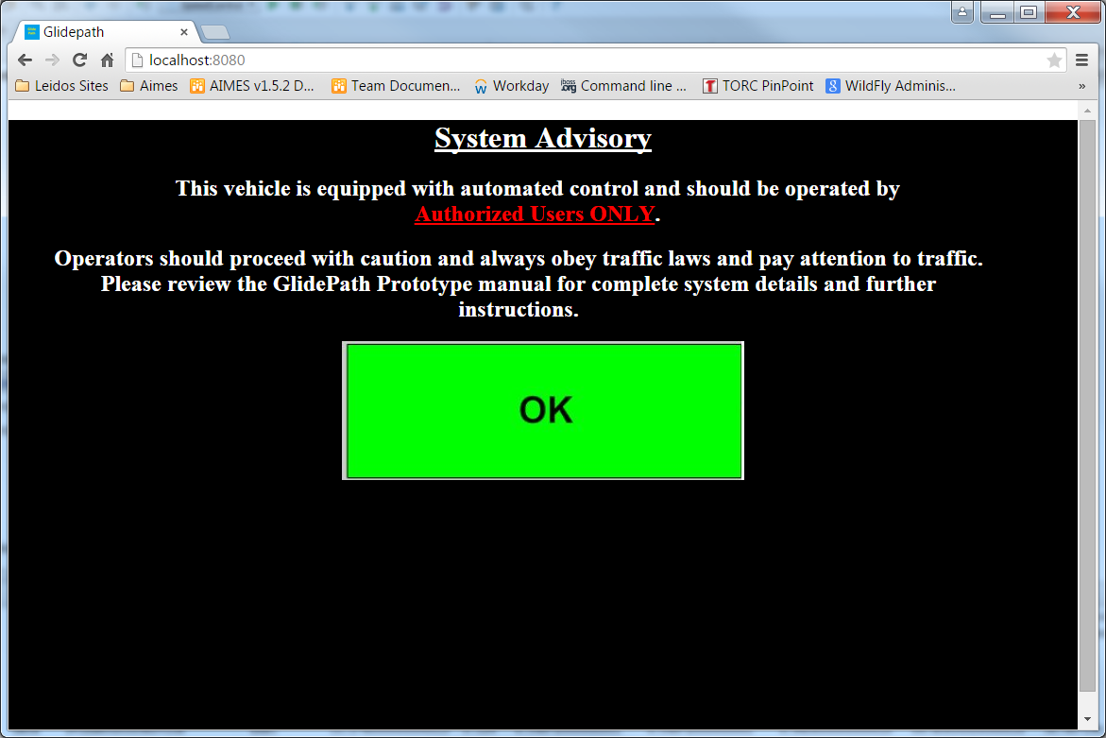

Once the Ok button is selected, the Status page is displayed. From this page, the user can set an Operating Speed. Once all LED indicators are green, the user can press the GO button to engage EcoDrive. This display also visually displays SPAT countdown to enable starting experiments at predetermined times.

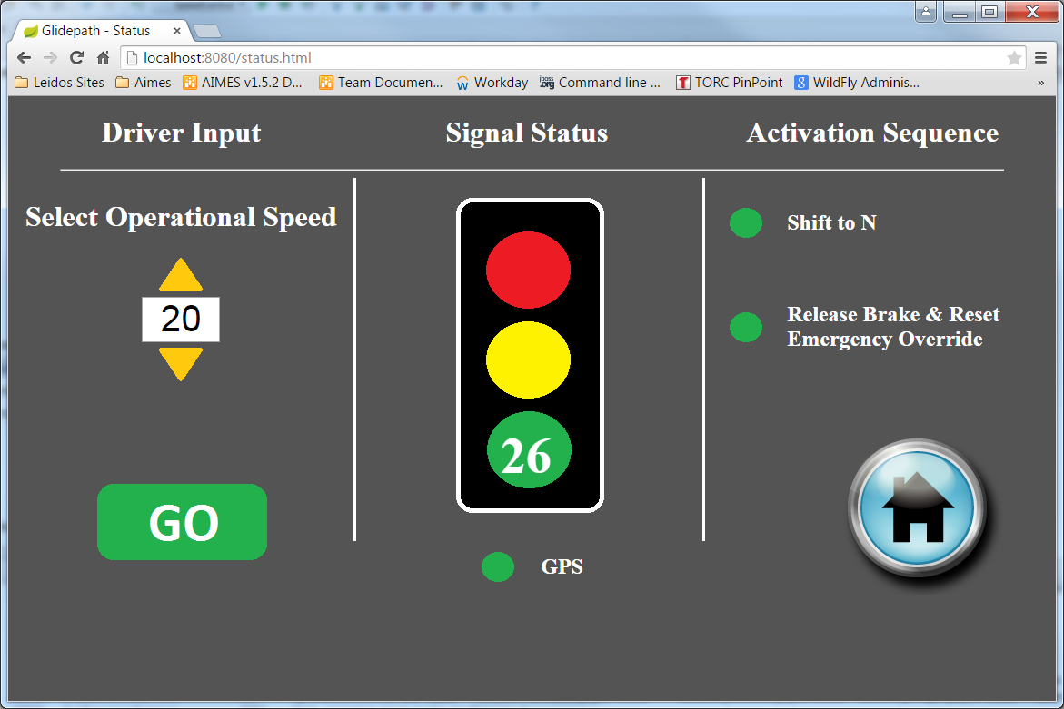

Once the GO button is pressed and the vehicle engages EcoDrive, the Driver View pictured below displays.

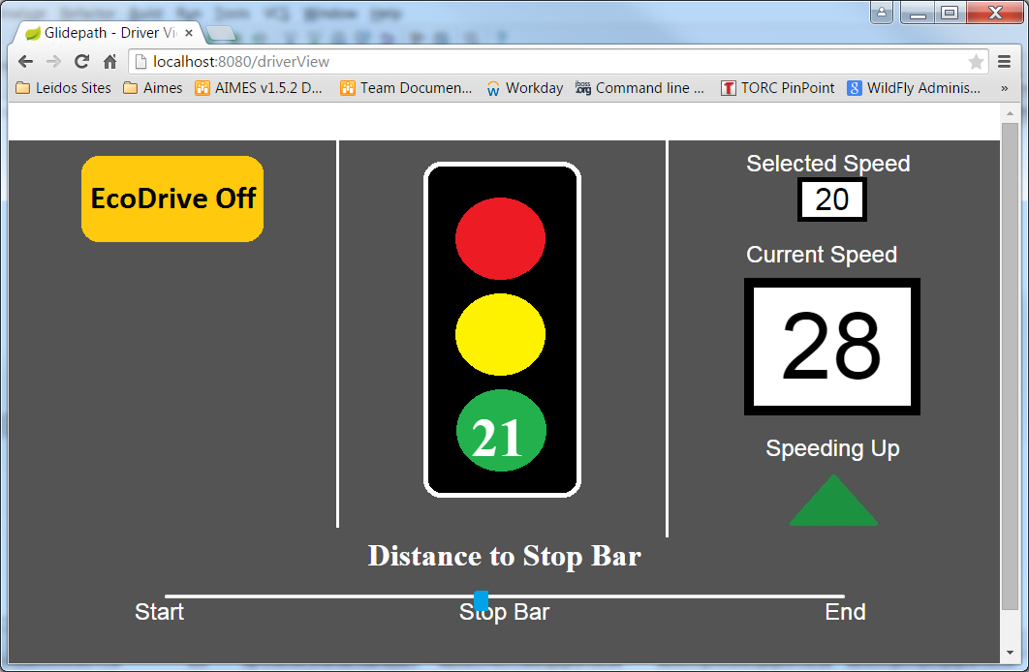

Once the experiment is completed, the log is automatically saved and the user is informed to rsume manual control and then the UI returns to the Home page.

|  |
| --- |
|  |

##### XGV Handler Package Detailed Design

The purpose of the XGV Handler software component is two-fold: it provides capability to read information about the vehicle state and provides capability to control the speed of the vehicle through the XGV’s Motion Profile Driver. To accomplish these it communicates with the XGV over the vehicle’s network using SAE AS-5669 (JUDP) communication protocol. This protocol provides the means to encode and transport the standard set of JAUS 3.3 and 3.2 messages as well as a set of experimental messages (particularly those pertaining to the Motion Profile Driver). This communication happens via UDP over port 3794, as assigned to JAUS by the IANA. The XGV Handler acts as a JAUS node on the XGV’s network, with its own configurable JAUS ID.

The structure of the XGV Handler package is shown in Figure 13 below. Its individual classes are described next.



Figure 13. XGV Handler class diagram.

The XgvConnection class handles the communication with the XGV hardware itself and acts as a way to store connection context so that it can be shared between the temporary Callable threads that require its functionality. The XgvConnection acts like a socket where possible, except that it ensures that the data coming in and going out adheres to the JUDP and JAUS standards by formatting and parsing packet and message headers. It also provides methods to wait for JAUS messages of certain command codes to arrive and helps to manage component ownership by making control requests.

The XgvInitializer class creates the XgvConnection to be used by all the other Callables and sets up the XGV device to receive commands from and be queried/controlled by the other Callables. It initializes the XgvConnection object then waits to receive a heartbeat pulse from the XGV device.

Once the connection to the XGV is successfully confirmed by the XgvInitializer it gives a confirmation to the invoking executor that it is okay to proceed with operation of the executor’s XgvConsumer and XgvSpeedController objects. The XgvConsumer’s call() method is invoked every time step by the executor. This call() method causes the XgvConsumer to query the component status of the XGV’s Motion Profile Driver, the velocity as recorded by the XGV, and the state of various discrete devices as recorded by the XGV. All of these queries occur by utilizing a method on the XgvConnection instance to construct and send a specific query packet and then utilizing a second method on the XgvConnection to wait until a response with a specific identifier code has been received. From the results of these queries the XgvConsumer creates an XgvStatus object which contains all of the parsed data fields from the responses. The XgvConsumer returns this XgvStatus object as well as the speed value the XGV reported to the executor that invoked it.

The XgvConnection should be closed when the XGV functionality is no longer needed (if Glidepath is terminated or if the vehicle enters a state from which the XGV should be reinitialized) so it can terminate the connection to the XGV device and close its UDP sockets. Closing the XgvConnection also releases control of any JAUS components it has claimed control of (generally only the Motion Profile Driver during normal operation).

The XgvSpeedController class sends speed control commands to the XGV device. It makes use of the XGV’s Motion Profile Driver component and sends it a motion profile consisting of one motion for a single time step: accelerate to the commanded speed. This speed should be the output of the EAD algorithm software for the given time step. The XGV will automatically control the application of throttle in an attempt to reach this speed over the next time step.

When the XgvSpeedController’s sendMotionProfile() method is invoked by the Executor it first attempts to verify that the XGV Handler has control of the Motion Profile Driver JAUS component. If it does not, the XgvSpeedController will attempt to send the necessary messages to gain exclusive control of the Motion Profile Driver as this is required to control the vehicle. Once it has re-verified that it was successful in gaining control (or still retaining control) the XgvSpeedController will command the XgvConnection to construct and send a new Set Motion Profile command packet based on a target speed value provided by the EAD algorithm.

The JausMessage class represents messages that can be sent to or received from the XGV via the JAUS protocol. Instances of the JausMessage class are either constructed by converting from binary data (parsing being done by the JausMessage constructor) or by supplying values for the necessary fields in a normal fashion. JausMessage objects are responsible for their own serialization for network transmission via their serialize() method. This allows the XgvConnection to not need to know about the contents of any given JausMessage in order to transmit it. Specific messages that have payloads that need to be parsed such as the Report Status Message and Report Velocity State message are created as subclasses of JausMessage so that they can also parse their payloads and provide methods to access that data.

The XgvStatus class contains information on the current state of each XGV component (Initialize, Standby, Ready, Emergency, or Failure) as well as any active error or warning codes being reported by the XGV and the state of discrete devices such as the transmission, horn, doors, and engine. It is created during the XgvConsumer’s call() method by querying the XGV for this data. It is primarily a data transfer object to pass this data to other areas that need to use it.

##### EAD Package Detailed Design

The EAD package contains 15 classes and two interfaces that serve three purposes. They are shown in the following class diagram.

Figure 14. EAD class diagram.

The first group of items represents the speed trajectory at its highest level. The ITrajectory interface defines the exposed interface of this package to the rest of the application. It provides an engage() method that the executor uses to communicate whether the automatic control (the XGV device) is engaged and thus requires speed commands from the EAD. The primary method in this package is getSpeedCommand(), which invokes the remaining code in the package to compute an appropriate speed command for the current time step given the sensed vehicle situation. The TrajectoryFactory class allows the executor to choose at run time whether the real control mechanism is used, by instantiating a Trajectory object, or a SimulatedTrajectory object is instantiated. The latter is useful for testing other application components, as it avoids having the physical vehicle on the road. The getSpeedCommand() method, provides several pieces of logic besides simply invoking the command calculation classes. First, because it depends on several vehicle state values, it validates all of these inputs. It senses receipt of a new MAP message and manages the creation of an intersection geometry model based on it; this allows transition from one intersection to another, or changing geometry of the current intersection (e.g. a lane closure). A configuration parameter allows any given intersection to be used or ignored (by intersection ID). Once the geometry model is created and it resolves the vehicle position to a unique lane within the intersection, the remaining logic is invoked. It first commands the vehicle to accelerate to the operating speed (OS) at the beginning of an experiment run. Only after OS is achieved and held for a configurable duration, and after the vehicle has gotten close enough to the stop bar (a configurable parameter), the Trajectory class then does one of two things. First, it can use a trajectory file to determine the speed profile. This is a pre-existing CSV file that specifies speed commands for each time step. Second, if no trajectory file is specified in the config file, then it invokes the chosen EAD algorithm to calculate a speed command. Once a speed command has been determined for the current time step, the getSpeedCommand() method passes it through a command limiter, which ensures that the commands don’t violate the configured limits on acceleration, deceleration, or jerk. Finally, it computes a fail-safe command override. This logic is a backup calculation that ensures the vehicle will not drive through a red light. It overrides the computed speed command if it appears the computed command will violate the red light rule.

The second group of items provides the detailed computations for the specific type of trajectory chosen. This group is on the right side of the class diagram. It begins with an EadFactory class that the Trajectory object uses to choose, at run time, which trajectory algorithm to use. All of the algorithms are embodied in classes that inherit the common methods in EadBase, which in turn implements the IEad interface. Thus adding a new algorithm requires only the creation of a new child of EadBase and it can be used with a run time decision, which is based upon a setting in the config file. The EadDynamics class is not for operational use, but is intended for measuring the dynamic response of the vehicle and control system to various command input parameters. This was used to tune the failsafe algorithm. The EadSimple and the EadUcrJava classes are similar in that they control the vehicle through the four possible approach scenarios (cruise through at the OS, speed up to beat a yellow light, slow down to wait for red to expire, or full stop). The EadSimple model uses a straight-line trajectory shape, where the speed command changes linearly from the OS to the ultimate target speed. The EadUcrJava model implements UCR’s trigonometric trajectory shape to maximize fuel economy. In both models the acceleration and deceleration use the maximum values specified in the config file. The EadUcrStraightSlowdown class performs identically to the EadUcrJava class for three of the driving scenarios; in the slowdown scenario it provides two varieties of straight-line slowdown, which are intended to feel more natural to a human passenger. The straight-line can begin immediately upon the decision to slow (ramping down at a configurable deceleration), or it can be configured to wait as long as possible before beginning to slow at the configured deceleration.

The third group of items models the intersection geometry and the vehicle’s relationship to it. The Intersection class manages the full geometric model of the intersection and the vehicle’s position relative to it. This includes trying to associate the vehicle with a particular approach or egress lane and determining its distance to the stop bar of its approach lane (even once the vehicle transitions to an egress state its position can be expressed as distance to stop bar (DTSB), which refers to the stop bar of its approach lane. To determine the lane association the Intersection class uses a LaneGeometry object for each lane defined by the MAP message. This class in turn borrows the Lane class from the ASD package, which holds the MAP’s offsets and reference location. The LaneGeometry class breaks this information down into generic 2D models of points and line segments using the LineSegment2D, CartesianPoint2D and CartesianVector2D classes. These create a flat-Earth model of the geometry centered on the intersection reference point, which is a reasonable approximation to the ellipsoid model over the distances involved in a typical intersection.

##### Filter Package Detailed Design

The Filter package provides a mechanism to smooth inherently noisy raw data by removing noise. It is a generalized package that uses polymorphism to allow selection of a particular filter model at run time. This version of the application includes three different filter models.

The IDataFilter interface provides the externally facing interface to the rest of the application, and all filter models must implement this interface. The application will use the DataFilterFactory to instantiate a filter using the model of choice. Once it is instantiated, the application will refer to it as an object of type IDataFilter. The class structure is shown in Figure 15. The interface provides methods to initialize and to add raw data points. It provides output methods to get a smoothed value replacing the most recent raw value, and to get (smoothed) first and second derivatives of the raw data. The intent is that the raw data stream will represent vehicle speed, and the first and second derivatives are used to represent acceleration and jerk, respectively.



Figure 15. Filter package structure

The filter intended for use in all of the Glidepath operations is embodied in the PolyHoloA class. It implements a hybrid filter. The first part is a second order polynomial fit to the most recent 15 historical data points to give a smoothed value of the base data stream. The second part is the Holoborodko algorithms for the first and second derivatives of the base data. For the first derivative 15 historical points are used, and for the second derivative 11 historical points are used.

##### ASD Handler Package Detailed Design

The ASD Handler contains nine classes in addition to two subordinate packages. Its structure is shown in Figure 16.

TheUdpForwardConsumer class provides an abstract implementation of the IConsumerTask. This class forms the basis for the MapConsumer and the SpatConsumer. Its call() method is called every time step and returns the appropriate data retrieved by its concrete derived Consumer. The common functionality for MAP and SPAT are contained in this class.

An IAsdMessage provides an interface that provides a parse() method. The interface implementations for this interface are MapMessage and SpatMessage. These classes provide the custom parsing of the raw UDP DSRC data stream into their respecitive representational objects. Data required for logging or destined for the UI are provided in the DataElementHolder returned by the call() method.

The AsdMessageFactory is used to create a concrete IAsdMessage object. The AsdMessageType enum is used to indicate whether the object is a MapMessage or SpatMessage.

The LaneSet and Movement classes are used to mirror the ICD specifications associated with a SPAT packet so that the entire Spat message can be retrieved.

The AsdInitializer class simply sets up a listener for the appropriate types of messages (MAP and SPAT) coming from the ASD device.

The MapMessage class represents a MAP message received from the ASD. This class provides the capability to store the raw buffer and extract the meaningful data elements from it.



Figure 16. AsdHandler class diagram.

Per the standard Glidepath device pattern, the Executive invokes the UdpForwardConsumer’s initialize() method, which does some basic setup, then returns a reference to the AsdInitializer.

The Executive then invokes the AsdInitializer’s call() method in parallel to all the other initializers. This method attempts to get a valid MAP or SPAT message from the ASD device. It doesn’t parse the message in detail, just looks at the header to be sure it indicates one of these two message types, and verifies that a message payload of the indicated size is present. Upon doing so the initialization of the handler is complete. If either a MAP or SPAT message is not received within a set timeout period, the initializer fails and the application stops.

When the software leaves its Sw-Setup state, the Executive will start its 10 Hz loop and invoke the respective UdpForwardConsumer call() method in each time step (it has a MapConsumer object and a SpatConsumer object that inherit this method).

##### CAN Handler Package Detailed Design

The CAN Handler component of the application consists primarily of a CanConsumer object and several objects which wrap the SocketCAN API for use in Java. While the CAN Handler component isn’t presently integrated in the Glidepath application it is kept as part of a foundation for future expansion of the application’s capabilities.

During the implementation and testing phase, it was determined that the post experiment data analysis would not require any CAN related data. Additonally, it was determined that the Glidepath vehicle did not provide Mass Air Flow through standard CAN PID requests (the sole parameter initially desired for post experiment computation). Although the capability to acquire CAN data is highly desirable, it was not necessary for Glidepath purposes so the reduced priority prohibited fully testing the CAN software.

The CanConsumerInitializer class handles the initialization of the CanSocket state. It opens the CanSocket object and then adds a list of CAN IDs to the filter. These CAN IDs are received from the configuration file.

The CanConsumer class is an IConsumer Task that communicates with the SocketCAN API to handle transmission and reception of CAN frames. The CanConsumer’s call() method sends a configurable set of CAN frames that request defined PIDs from the CAN bus. The CanConsumer then waits a number of retries in which it attempts to acquire matching responses for each request it sent out. Once it has exhausted its maximum number of retries or received a response for each request it parses the data contained in each frame and returns the data to the invoking Executor.

The CanSocket class wraps the low level raw socket from the SocketCAN API exposed by the Linux kernel in a Java Native Interface framework to enable calls from the Glidepath application into the lower-level C code needed to operate the SocketCAN API. The CanSocket class invokes the appropriate C functions to open, close, read, write, and set the socket properties for the SocketCAN socket. This enables the CanConsumer to send and receive CanFrame objects (translated to and from the appropriate C data structures by the JNI C code) and manage the CAN ID filters.



Figure 17. CAN Handler structure.

##### Localizatioin Handler Package Detailed Design

The Localization Handler accesses the Pinpoint Localization Message Server to acquire time-stamped position and attitude estimates in the global frame. The class diagram in Figure 18 shows the classes involved in consuming the GPS data from the Pinpoint device.

* The IConsumerTask interface extends the Java Callable interface and requires implementations for initialize() and terminate().
* The GpsConsumer class implements the IConsumerTask interface and owns a GpsInitializer object and a NioUtils object. It is responsible for managing the device interactions, collecting data and packaging it for transmission to the Executor.
* The GpsInitializer class performs the Pinpoint protocol handshaking required to use the Pinpoint API. It implements the IConsumerInitializer interface.
* The NioUtils class provides several low-level methods to support network channel communications.



Figure 18. Structure of the Localization Handler package

When the GpsConsumer is initialized, it creates a TCP SocketChannel and UDP DatagramChannel, which will be used by the initializer to communicate with the Pinpoint device. The initialize method constructs an IConsumerInitializer object that can be used by the Executor to initialize device consumption along with initializing other devices concurrently.

The GpsInitializer connects to the configured port of the LocalizationMessageServer on the Pinpoint device. Once connected, it performs protocol handshaking according to the process depicted in Figure 19 below. At this point the software is ready for full operation and awaits the Executive to initiate its 10 Hz timing loop. Within this loop the GpsConsumer’s call method is invoked, which polls the PinPoint device for the latest vehicle position. It then packages that position data into a DataElementHolder, containing timestamped latitude and longitude, which it returns to the Executive. The Executive can then combine this data holder with data from the other sensors to be passed into the EAD Algorithm Library. In addition to acquiring Global Position information, the call() method responds to UDP Pings from the Pinpoint device for each cycle. This ping response modifies a single byte of the Pinpoint ping and echoes back the ping to the device.

When the Executor terminates GPS consumption, the GpsConsumer terminates TCP and UDP connections.



Figure 19. Sequence diagram showing communication with the PinPoint device

##### Logger Package Detailed Design

The logger package handles data logging to file. Logger access is provided through the LoggerManager static class. Every class in the application that will do any activity logging will request its own instance of ILogger from the LoggerManager. Each of these objects stores LogEntry objects (representing individual events being logged) in an internal LogBuffer object. All unwritten entries are written to file only when the LoggerManager method writeToDisk() is invoked.

The logger component provides debug, info, warning, error, and output levels of “severity” (listed increasing) to classify log entries. It also provides ways to tag log entries as well as records the class the originating logger was associated with. This additional data is provided by the multitude of different log generating methods in the ILogger interface and Logger class. There are two implementations of the functionality, which can be chosen at runtime via a configurable parameter. The legacy capability is the set of classes on the right side of the diagram, which was used exclusively through software version 1.6. There is now an option to choose Log4jLogger, which encapsulates the popular third-party Log4j component to provide a more robust capability that is not susceptible to multi-threading issues that may be present in the legacy code.



Figure 20. Structure of the Logger package

Logger behavior is shown in the following two sequence diagrams. Figure 21 shows the initialization and typical use of the Logger package to record information, in this case an error message. As the Executor is starting up it specifies the filename that will be used for the persistent log data. It then requests of the static LoggerManager class a new logger for itself via the getLogger() method. In this diagram that object is referred to as the Executor.Logger, and it creates its own LogBuffer. Typical of setting up the other objects in the software, the Executor creates an XGV object, which then invokes LoggerManager.getLogger() to create its own Logger object with its own buffer. Later in the setup the Executor creates the DVI object, and it invokes the LoggerManager to register as a listener for various types of messages from various sources. In this example we show that it is registering to listen to both the Executor and to the XGV’s loggers.

Once everything is set up, then the program begins executing. At some point the Executor identifies an error condition and invokes its Logger.error() method to record the pertinent information. This method creates a new LogEntry object to hold this information, then inserts it into its LogBuffer. Because, in this example, the DVI has been registered as a listener, it forwards this LogEntry to the DVI via the LogListener interface.



Figure 21. Sequence diagram showing Logger setup and typical use

The next sequence diagram, Figure 22, shows an example of what happens at the end of a time step when it is time to update the log file. Until this point all logged information has been stored in memory in the various LogBuffer objects. Now the Executor invokes the LoggerManager to write these new entries to disk. The LoggerManager creates a new LogBuffer for itself, to collect all of the various LogBuffers’ contents. It loops through an internal list of all registered Loggers, invoking their getBuffer() methods to retrieve the actual buffers. Then on each buffer it invokes the merge() method to merge it with the growing master LogBuffer, respecting chronological order of all entries. When all Loggers’ buffers are merged, the LoggerManager invokes its master LogBuffer’s write() method to flush its contents to the disk file.



Figure 22. Sequence diagram showing writing to the log file.

##### App Common Package Detailed Design

The App Common package holds several utility classes that have wide use across the application. Its structural content is shown in the Figure 23 class diagram. The application uses a DataElement as the basic type to represent data exchanged to/from the various hardware interfaces and the EAD algorithm. Each DataElement represents a single quantity, and incorporates a time stamp representing when it was created so that its age can be judged. Sensory data that is stale needs to be flagged because it could lead to improper trajectory calculation. The DataElement class itself is never instantiated, but one of its subordinate classes is used to represent a particular type of data.



Figure 23. App Common class diagram.

Often it makes sense to bundle several data elements together for more efficient communication. In these cases a DataElementHolder is created and the individual DataElements are added to it, each with its own DataElementKey as a key/value pair. Then they can be handled as a single group of related data (e.g. all the latest readings from the XGV device). Each element can easily be retrieved from the holder by name using its storage key.

### Performance Estimates

The software is designed to minimize elapsed wall time required for each time step during the experiment. There is a risk that some of the processing will exceed its allotted budget, most likely in the XGV thread since it will involve the largest number of data elements being passed. Also, since we are not using a purpose-built real-time operating system, it is possible that occasionally the Glidepath software’s execution will be superseded by a high priority system process for a while. However, we have extensively tested the software and find that the 10 Hz processing loop executes in less than 100 ms well over 99% of the time. In those rare time steps that take more than 100 ms, the software is designed to handle it gracefully and keep on processing. When this happens, we simply have more vehicle motion than in an ideal time step, but at the operating speeds this project works with, there is not enough motion to induce large errors, even if a time step takes 300 ms (which is extremely rare).

## Concept of Execution

Figure 24 is a state diagram specifically representing the Speed Control Application. It maps to the system level state model shown in Figure 3 and Table 2, as shown in the notes within the diagram. The Executor Service is solely responsible for managing the state model of the application; no other packages have state awareness. The Sw-Setup state is intended to last however long is necessary to startup the application, deploy the web application, and acquire the list of device consumers. Once device initialization begins, the state transitions to Sw-Startup. While in Sw-Startup, the software initiates connections to consumer devices and RSU output streams. Once all consumers have initialized successfully, the state transitions to Sw-Standby. In Sw-Standby, the user can observe that the system is ready. The SPAT status is conveyed through a Signal image and the signal transition countdown is displayed. Additionally, a green GPS LED indicates that both the intersection geometry has been calculated from the MAP message and that the GPS has indicated the vehicle position within a lane. Once the experimenter is ready, the vehicle is put into automatic mode by shifting into Neutral and resetting the emergency button. At this point, the Speed Control Application is fully operational and logging both sensed data and calculated speed commands at 10 Hz, but the speed commands are not being fed into the XGV controller. Only when the experimenter commands EcoDrive ON, via the DVI GO button, does the software transition to the Sw-Engaged state and actively provide speed commands to the XGV controller. If the experimenter commands EcoDrive OFF, via the DVI, or presses the emergency button or brake pedal, the software will transition back to the Sw-Disengaged state. Note that it cannot transition back to the Sw-Engaged state until the emergency button is reset.



Figure 24. Speed Control Application state model

Figure 25, below, illustrates the processing cycle performed at 10 Hz.

The two primary DVI classes involved in the cycle are the DviExecutorService and the PeriodicExecutor. Every 100 milliseconds, the DviExecutor service obtains a new thread from a thread pool to execute the PeriodicExecutor call() method.

The PeriodicExecutor maintains a list of all IConsumerTasks. For Glidepath, these consist of the XgvConsumer, GpsConsumer, MapConsumer, and SpatConsumer (CanConsumer exists, but is not currently used). Each of these Consumers is executed on its own thread so that processing can be performed simultaneously.

The container used to collect the data from each IConsumerTask is a DataElementHolder. A DataElementHolder contains a set of DataElements. Each IConsumerTask collects data specific for their devices. For example, the GpsConsumer collects Latitude and Longitude and compiles that in a DataElementHolder returned to the PeriodicExecutor each cycle. Similarly, the XgvConsumer acquires Speed, Gear Shift Position, etc. and packages its data into another DataElementHolder returned to the PeriodicExecutor.

The PeriodicExecutor collects all data from the individual IConsumerTasks and builds a new DataElementHolder containing all collected data. Once all data has been collected, it computes data derived from data collected from the individual IConsumerTasks. Some examples of calculated data include: Motion Status, Smoothed Speed, and Acceleration.

Additional processing includes obtaining the SPAT information for the specific lane in which the vehicle resides.



Figure 25. Major communication pathways

The PeriodicExecutor also determines if the brake or emergency override has been triggered. If this occurs, the Speed Control Application is stopped and the driver is warned to retake manual control.

From here, the Periodic Executor calls the ITrajectory interface to acquire target speed. The data collected from the IConsumerTasks is provided to the ITrajectory so that the desired target speed can be calculated.

Once a target speed is acquired, if the state is ENGAGED, the XgvSpeedController is provided the target speed to automate the vehicle trajectory.

At this point, the PeriodicExecutor’s work is done for the cycle and the DataElementHolder containing all data is returned to DviExecutiveService. The service then logs the data for post run analysis and also provides data to the Web UI, generally every 5 cycles; approximately every 0.5 seconds.

Web UI actions (user pressing buttons, etc.) are handled by the DviController. These actions are subsequently processed using capabilities within the DviExecutiveService or other DVI classes.

## Interface Design

Following is a summary of the various I/O flows going across the system boundary:

* Incoming SPaT messages at up to ten Hertz (10 Hz). These will be formatted according to the FHWA message standard. They will be received by the vehicle’s DSRC ASD component from one or more fixed RSUs.
* Incoming MAP messages at one Hertz (1 Hz). These will be formatted according to the FHWA message standard. They will be received by the vehicle’s DSRC ASD component from one or more fixed RSUs.
* Standard GPS signals received from the national GPS satellite constellation at ten Hertz (10 Hz). Once received by the vehicle’s PinPoint localization component, the signal will be fused with data from the onboard IMU to deduce a precise vehicle position and attitude.
* The XGV is queried for state information such as Speed, Gear Position, Emergency Override and other XGV specific parameters.
* Wi-Fi messages will be both transmitted and received by the In Vehicle Processor. Outgoing messages will contain performance data that can be viewed on a DVI web browser. These data packets will be transmitted via Ethernet (Wi-Fi) at a configurable frequency. Although the DVI tablet will be part of the system, and is intended to be riding within the vehicle during an experiment run, these Wi-Fi signals will be available to any other 802.11 receiver within range of the vehicle’s Wi-Fi radio. Incoming Wi-Fi messages from the tablet’s view of the DVI will contain user commands from the DVI, and will be transmitted whenever the commands are generated.

# Appendix A: Datasheets

## NTCIP Traffic Signal Controller – Econolite ASC/3-2100



## NTCIP to FHWA SPaT BlackBox – Advantech UNO-2178A



## DSRC Roadside Unit – Arada Systems Locomate RSU



## DSRC After-market Safety Device – Arada Systems Locomate ASD/OBU



## Positioning System – TORC PinPoint



## In-Vehicle Processor – Axiomtek tBOX312-870-FL



## AP Router – CradlePoint MBR1400



## Network Switch – Danpex KN-S7210G

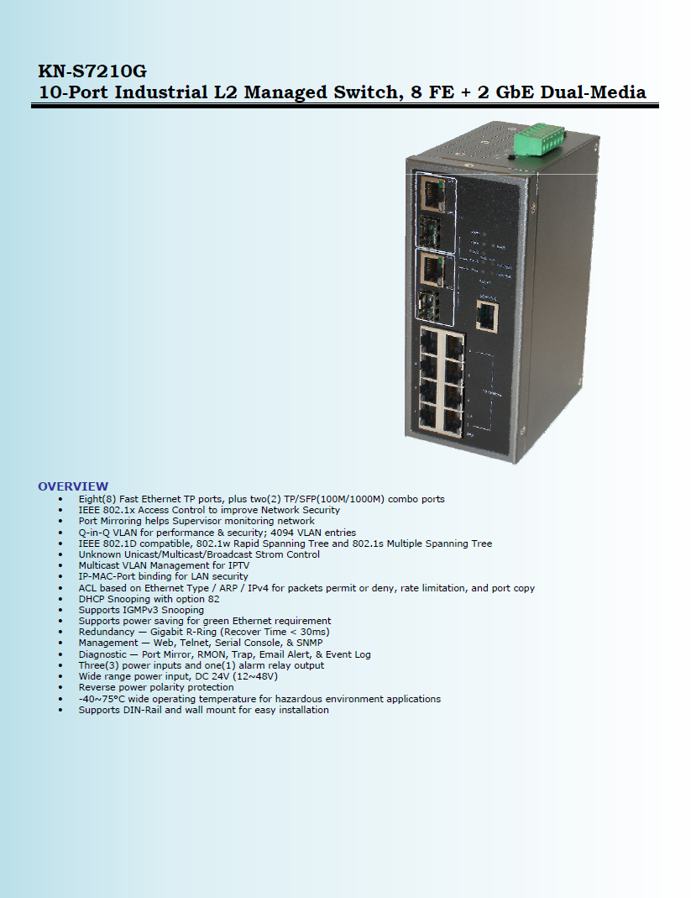

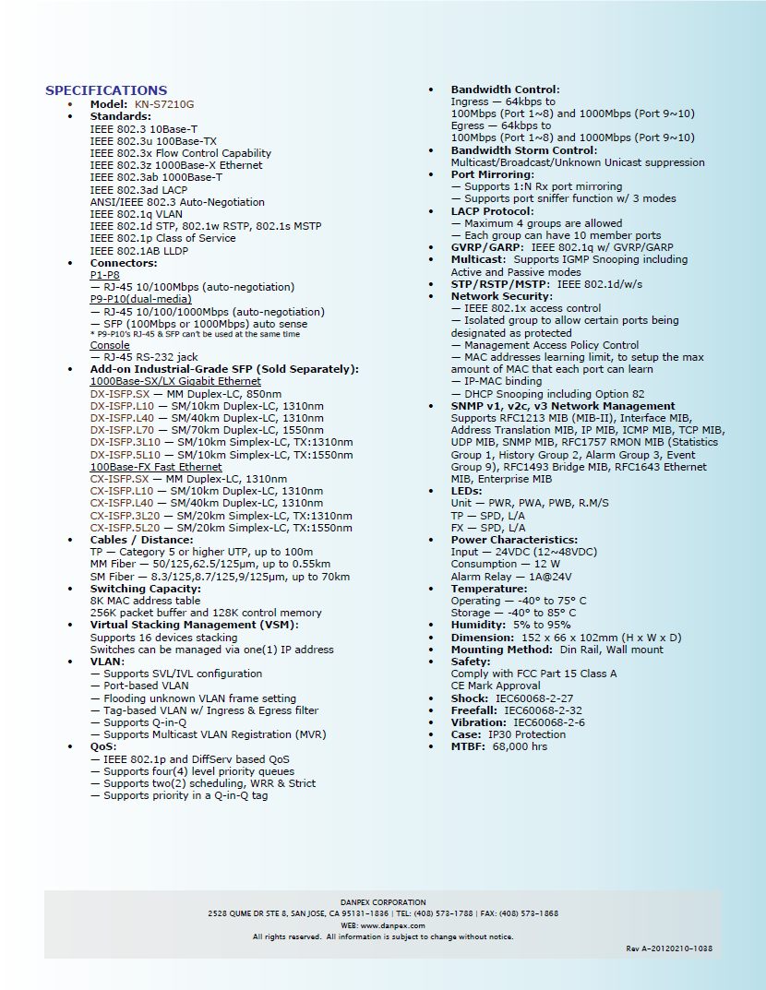

## Driver Vehicle Interface – Panasonic TOUGHPAD JT-BI



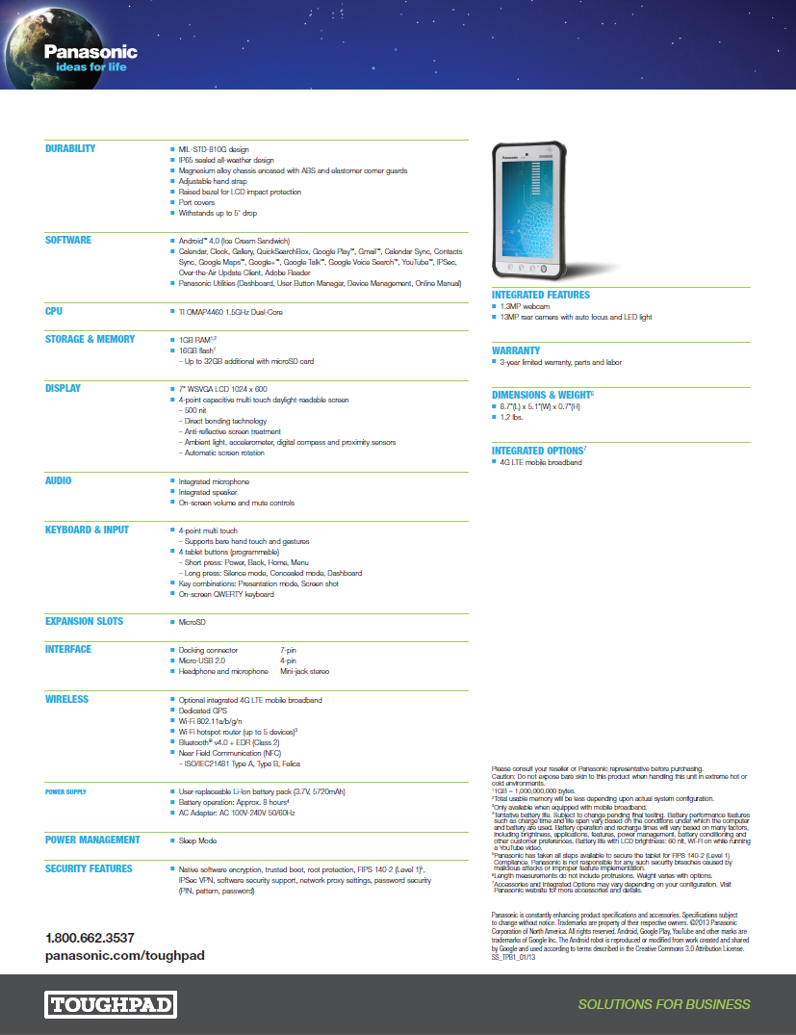

## Vehicle Electrical/Power System – TrippLite AC UPS/Inverter SMART2600R



# Appendix B: Acronyms

| **Acronym** | **Definition** |
| --- | --- |
| AERIS | Applications for the Environment: Real-time Information Synthesis (AERIS) |
| AC | Alternating Current |
| AP | Access Point |
| ASC | Actuated Signal Controller |
| ASD | After-market Safety Device |
| CAN | Car Area Network |
| DC | Direct Current |
| DSRC | Dedicated Short-Range Communication |
| DVI | Driver-Vehicle Interface |
| EAD | Eco-Approach and Departure |
| FHWA | Federal Highway Administration |
| GID/MAP | Geometric Intersection Description (aka MAP) |
| GPS | Global Positioning System |
| HVDC | High-Voltage Direct Current |
| Hz | Hertz |
| I/O | Input/ Output |
| IMU | Inertial Measurement Unit |
| JAUS | Joint Architecture for Unmanned Systems |
| NTCIP | National Transportation Communications for ITS Protocol |
| NEMA | National Electrical Manufacturers Association |
| OBD | On-Board Diagnostic system |
| RSU | Roadside Unit |
| SAE | Society of Automotive Engineers |
| SPaT | Signal Phase and Timing |
| STOL | Saxton Transportation Operations Laboratory |
| TFHRC | Turner Fairbank Highway Research Center |
| TOPR | Task Order Proposal Request |
| UCR | University of California Riverside |
| UI | User Interface |
| UPS | Uninterrupted Power Supply |
| USB | Universal Serial Bus |

1. Requirements TO17_FUN_06 and 07 from the GlidePath Technical Requirements, listed as item 6 on the reference list in Table 1, specifies for the provision of two manual override control mechanisms.
2. Arada Systems uses the same model name for their Roadside Unit and After-market Safety Device; but each are referred to by their device types (RSU or ASD) throughout this document to prevent confusion.